cmca rv forum

Held in Brisbane on Tuesday 16 May 2017
  - Economic benefits to Somerset region by initiating a (trial) CMCA RV Park

THE KEY FACTS – What is a CMCA RV Park?

The CMCA Park Project is a new accommodation concept for self-contained RV tourists who are members of the Campervan & Motorhome Club of Australia Ltd (CMCA). CMCA RV parks are low cost, member only, no frills managed RV accommodation facilities and do not operate commercially.
CMCA is recognised by the Federal Government as a not-for-profit association and a tourism promotion organisation.
In essence, a CMCA RV Park is on land owned or leased by the CMCA with:
- Approximately one hectare of flat ground.
- Space for 20 to 40 RV’s.
- A dump point with a wash down tap, with potable water taps around the site.
- One (1) powered site for the 24/7 volunteer custodian.
- A shelter shed for gatherings and an assembly point.
- Access only available to CMCA members whose vehicles meet the CMCA Self-Contained Vehicle Policy.
- All maintenance costs including grass cutting and rubbish collection met by CMCA.
- An administration/booking fee of $3 per person or $6 per vehicle, per night.
The infrastructure development consists of:
- Access and roadways into and in the park, as required.
- Fences or bollards to restrict access to the main gate.
- The main gate and signage.
- The dump point and wash down tap.
- Potable water taps as required around the site.
- One powered site including the power connection for the custodian.
- A shelter shed and concrete pad.
- Any required levelling, landscaping and planting
All infrastructure development is organised and funded by the CMCA. Based on our experience this cost will vary depending on the site, but we expect development costs generally to be in a range of $50,000 to $100,000
CMCA will consider purchasing or leasing any suitable land, however we see mutual opportunities and benefits in partnering with local councils.
When viewed from a council perspective it should be noted that:
- CMCA seeks no financial or in-kind support from councils to develop the RV Park network.
- The lease of council land should be on the same basis as any other not for profit community association, such as a bowling club, pony club or the like.
- The CMCA will pay rates on the site.
- There is no cost to the council with all infrastructure developed and paid for by the CMCA.
- All maintenance is managed and paid for by the CMCA.
- All CMCA seeks from council is advice and support for any development application, or other local or State government approvals.
- It is an arm’s length financial arrangement with no hint of the council giving the CMCA a financial advantage.
- A CMCA RV Park will increase RV tourism to the area and increase the tourism spend with local businesses.
- Although access is restricted to CMCA members, any owner of an RV can join the CMCA. As the current annual subscription is $44, from a practical point of view any self-contained RV owner can use a CMCA RV Park.

Councillors, as you now understand there is no expectation for a financial commitment or contribution from council to make this venture happen. It will however, require collaboration, a suitable sublease agreement with CMCA, and an ongoing commitment to assist the not-for-profit association through the various stages to set the RV Park up.
I spoke to many CMCA Directors at the RV Forum, and I was surprised by each of the Directors attitude to our region, and in fact there was a great show of support for Somerset to be a future CMCA RV Park destination. As you will see from the forum slides contained in this report, CMCA’s goal is to have twenty RV Parks operational by 2019, and Somerset is encouraged to seriously consider exploring this opportunity at Kilcoy, at the area identified by Kilcoy Shire Council many years ago as a future Caravan Park. I am aware that all Councillors have visited the proposed site, past Seib Street. Council is currently planting trees in this area and the area was a visited site on the budget bus tour in April this year.
The town’s CBD is probably at its darkest vibrancy, and I say this as I have lived here most of my life, you can ask the business people or other locals, I am sure they will agree. The free camping provided at Anzac Park has assisted with foot traffic and economic benefits to the CBD area.

I posed the following question during Q & A to the CMCA, “Can an area have too many of the same style of camping options?” “Of course,” was the answer, but there is a need to evaluate all existing available camping and analyse further to provide an accurate answer to the question. CMCA ensures that it adds product to the market and offers a different dimension to what is already established. I learnt from the Deputy Mayor of Hinchinbrook, that this factor has not been an issue at Ingham, where there were five privately owned caravan parks prior to the establishment of the CMCA RV Park.
I am sure we have all witnessed when travelling, areas that have been rejuvenated by various initiatives. CMCA now have an RV Park in Railton, Tasmania and I remember travelling through Railton, and admiring the topiary - now known as the “Town of Topiary”. The little town situated between Latrobe and Sheffield has over 130 topiary characters along their streets. There are tea rooms, a brewery, secondhand store, a local craft gallery, Tasmania Trail links and other stores. The park for fully self-contained caravans and motor homes was very active and there were many campers in the park at the time we passed through. It certainly appeared to me to be the hub of the town. CMCA acknowledged that they have spent $70,000 at this site. There are other examples in Tasmania, where existing businesses have value added to their business, by providing free camping areas. The RV industry is only going to continue to grow and the economic benefit and tourism potential for many towns should be captured sooner, rather than later.
I spoke with Cr Mary Brown about Ingham’s experience, she had nothing but praise for the initiative, and in fact the CMCA RV Park has been so successful, a second RV Park is planned for Ingham. Cr Brown confirmed that the financial commitment by council is virtually nil with this project. Cr Brown also advised that her Council entered into an agreement with CMCA for a trial period of six months with the first project. Cr Brown’s presentation is included for your information.

CMCA Presentation Brisbane 16th May – by Deputy Mayor Mary Brown, Hinchinbrook Shire Council
Good morning Ladies and Gentlemen (and distinguished guests if any) My name is Mary Brown and I am currently Deputy Mayor of Hinchinbrook Shire Council and was previously President of the Chamber of Commerce for 8 years. Hinchinbrook Shire is situated approximately 115km north of Townsville and is a predominately rural community with several towns and townships spread across the shire - Ingham being the largest town. The current population of the shire is approximately 11130 residents.
This special part of the world has spectacular natural attractions where one can experience within one hour's drive of the shire boundaries, the longest single drop waterfall in Australia - that being Wallaman Falls, spectacular world heritage listed rainforest, a multitude of diverse geographic natural features, right through to stunning beaches and the magnificent Hinchinbrook Channel.
The economy of Hinchinbrook Shire has traditionally had a very strong reliance on agriculture and most particularly sugar cane production. Being a high rainfall region, situated on a coastal plain, cyclones or flooding can have a significant impact on the economy of the shire. Like many rural communities, our shire has experienced a population decline over the last 3 -4 decades, which has also seen a significant change in the demographic of the community.
This decline has been the impetus for economic diversification in the Hinchinbrook Shire, where the focus has been on developing other industries that can sustain the economy and hopefully rebuild the demographic mix.
Given our diverse natural attractions and relaxed lifestyle and connection via the national highway, tourism was one of the obvious choices for diversity.
The process commenced in earnest in 2006 when the council of the day engaged Robert Prestipino to undertake an assessment and consultation process which resulted in the document named "Our Town Our Future".
This process and the report produced resulted in the successful funding to establish Tyto Precinct, Stage 1 (wetlands, VIC) and subsequently Stage 2 (library, regional gallery, conference centre and restaurant), which was designed to be the central hub and catalyst of a future tourism industry
In 2014 HSC in collaboration with Hinchinbrook Chamber of Commerce, made the decision to undertake a 6 month, self-contained only, RV trial (April to October) at the TYTO precinct where a dump point already existed. Initially this trial, which had a 15-unit site capacity, was free and maximum of 48 hour stay. After review of the trial data, in the second year a decision was made to charge $10 per night per RV and visitation numbers did not reduce.
Initially the decision to trial was very controversial, especially with five traditional caravan parks in the shire. Much discussions with the van park owners and local sentiment was not overly supportive, as it was felt this decision would disadvantage the local rate paying businesses and give special treatment to these travellers, who it was perceived were not going to contribute to the economy of the community.
The trial used VIC staff to managing the site, each RV who wanted to stay had to register at VIC and it was requested they provide data relating to their spend, so that HSC could quantify the economic impact back into the community, as a result of the trial.
The surprising result of this trial was the value per day/unit spend back into the economy and the diversity of that spend. ($125 per day per unit for their RV site stay - purchases included fuel, food, pharmacy, retail, services and generally spend throughout the entire community). Also, it was shown many then recorded they extended their stay in other areas of the shire. Also, AND most significantly, over 88% of these visitors stated they never would have stopped in Hinchinbrook if it was not for the free site. The significance of this meant that we could assure our community that we were not negatively impacting the van parks, because these guests categorically stated they were never intending to stop anyway and only chose to because of the RV site.
So, this was NEW business for our shire. In the first year, within two weeks of the trial ceasing, local retailers were asking what had happened as they noticeable saw a decline in trade.

In 2015 CMCA negotiated to lease an unused parcel of land across the highway from Tyto precinct, to establish a 50 unit CMCA member only RV site as part of a membership drive for the club. CMCA caretakers would be positioned on site on a rotational basis. A dump point, fencing, small shed where members could gather for socialising and landscaping was invested into the site. Dependent on weather, the site is open from May to October each year. In the first year of operation (2016) the site reported economic benefit to the community of $10k to $12k per week, when site visitation was at its peak (July and August).
As a result of the increased visitation to the shire, HSC has now adapted the opening hours of the shire library and regional gallery (which are situated in the Tyto precinct) to operate 7 days per week. During that period, council also schedules events and activities to engage with the visitors to the sites, as well as locals.
In 2016 one of the local beach progress associations approached council to trial the establishment of a second RV site at Forrest Beach, on the site of an unused caravan park, owned by council. This trial commenced for two months of 2016, with good results and is again operational from April 2017 for another trial period.

A local rural pub with extra spare land, also established a free camping site as part of value adding to their business in 2015. All necessary council approvals were gained, with the owner being very proactive in the online promotion and marketing. This previously struggling business subsequently saw the development of the RV side of the business positively impact the sustainability of this property.
Whilst it's not all perfect and we still have challenges with rogue non self-contained visitation, however we continue to work through these issues, are looking to grow market share and importantly the traditional van parks continue to see good visitation, with several of these parks recently undertaking facility upgrades and also provide more social and entertainment services to their guests.
Council has now developed and rolled out a branding and marketing campaign, “The Hinchinbrook Way” which showcases the business and tourism aspects of the shire, as a way to continue to attract tourism, investment and "sea change" and family lifestyle markets. Council will continue to focus on tourism product development with local operators and encouraging investors to consider establishing in our shire. We acknowledge that the drive market will continue to be the most significant tourism sector for our shire for some considerable time to come and will continue to work to grow this market. If you are looking for a sea change in the north, our council is open to support new opportunities.... Anyone interested come speak to me at the end of the forum.
Thank you.
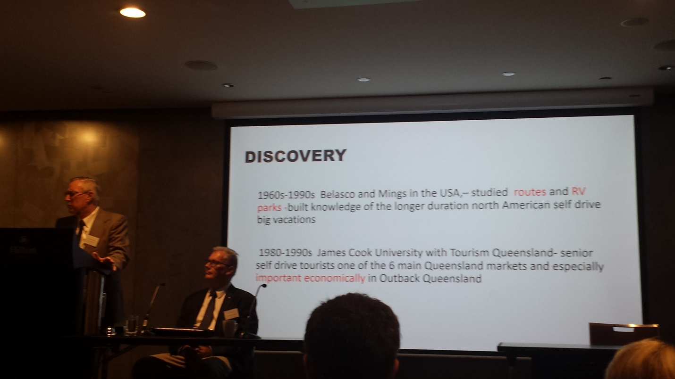
A bit of history with self-drive holidays as presented by slides at the RV Forum
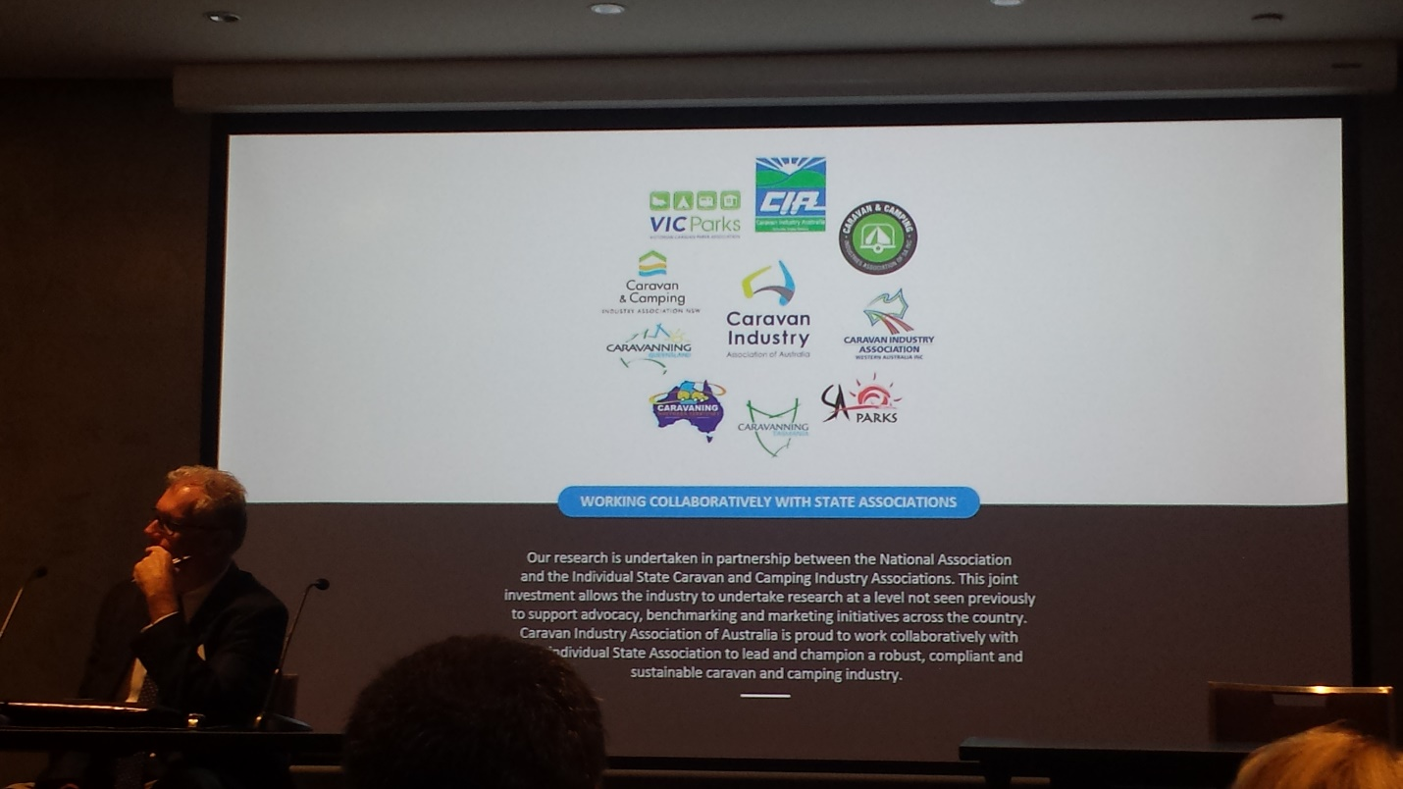
Working collaboratively with State Associations
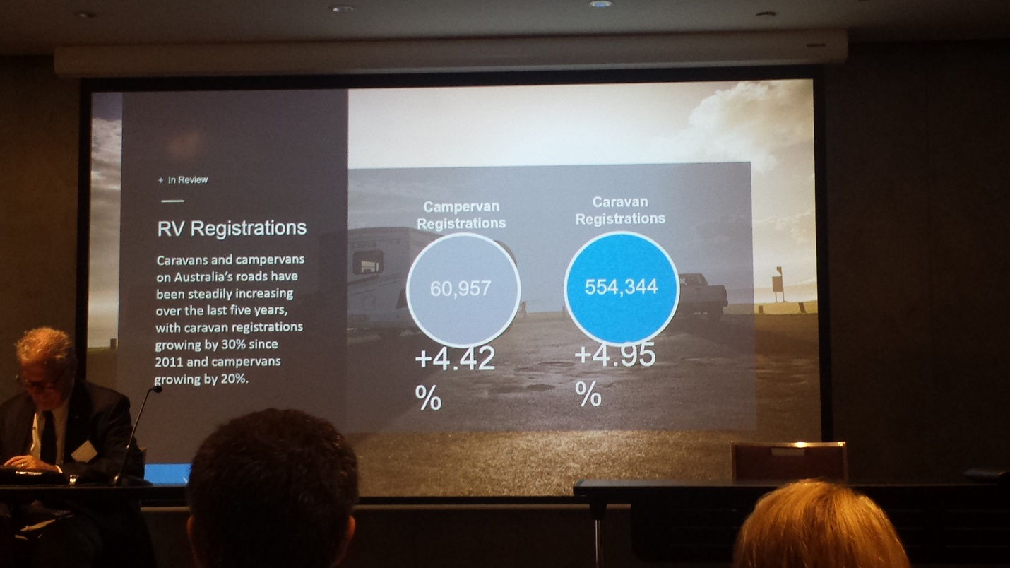
Some compelling statistics

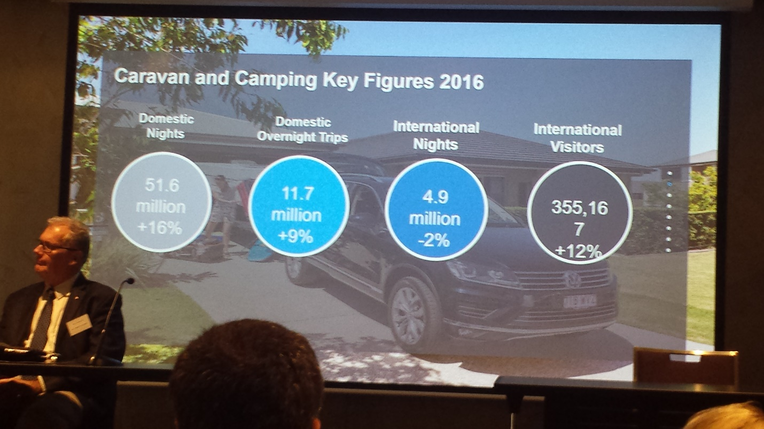
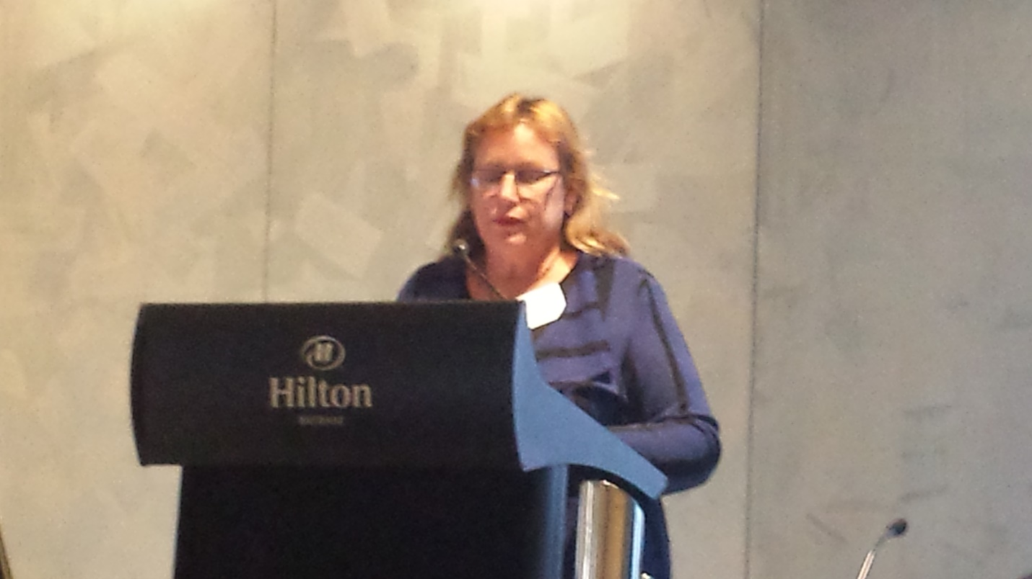
Hinchinbrook Shire Council’s Deputy Mayor Mary Brown offering her knowledge and experience with CMCA RV Parks at the RV Forum. Ingham has benefited immensely by the CMCA RV Park, the town is now planning for its second RV Park.

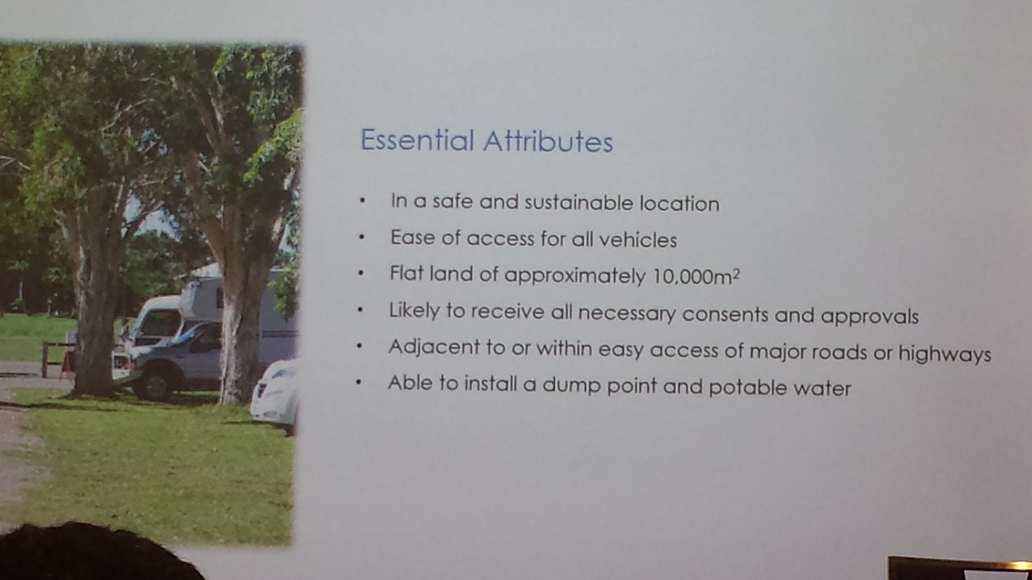
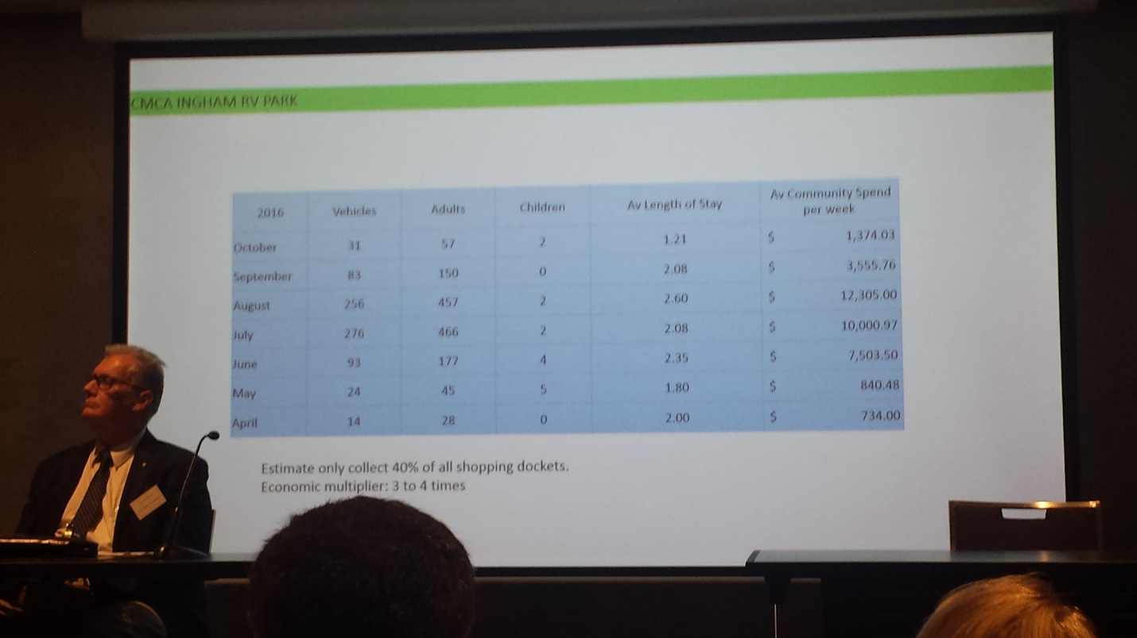

More compelling statistics

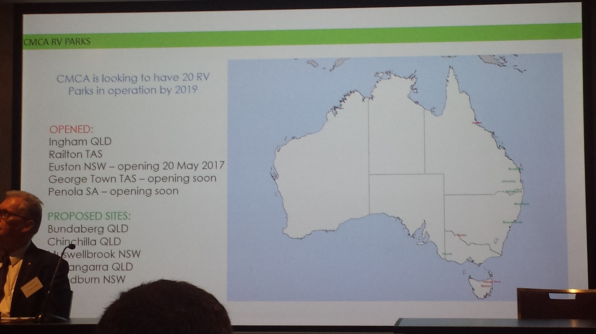
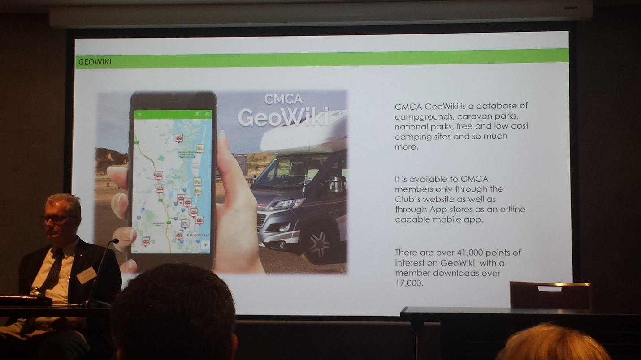

There are many benefits derived from the membership of CMCA

Cheryl Gaedtke
Councillor
Somerset Regional Council [ABN 50 138 958 249]
a | 674 Kilcoy-Murgon Road, Kilcoy. QLD 4515
p | 0428 408 227
f | 07 5424 4099
e | cherylgaedtke@somerset.qld.gov.au
w | www.cherylgaedtke.com
facebook | www.facebook.com/www.cherylanngaedtkeforsomerset.com.au
facebook | http://www.facebook.com/SomersetRegionalCouncil
w | www.somerset.qld.gov.au

